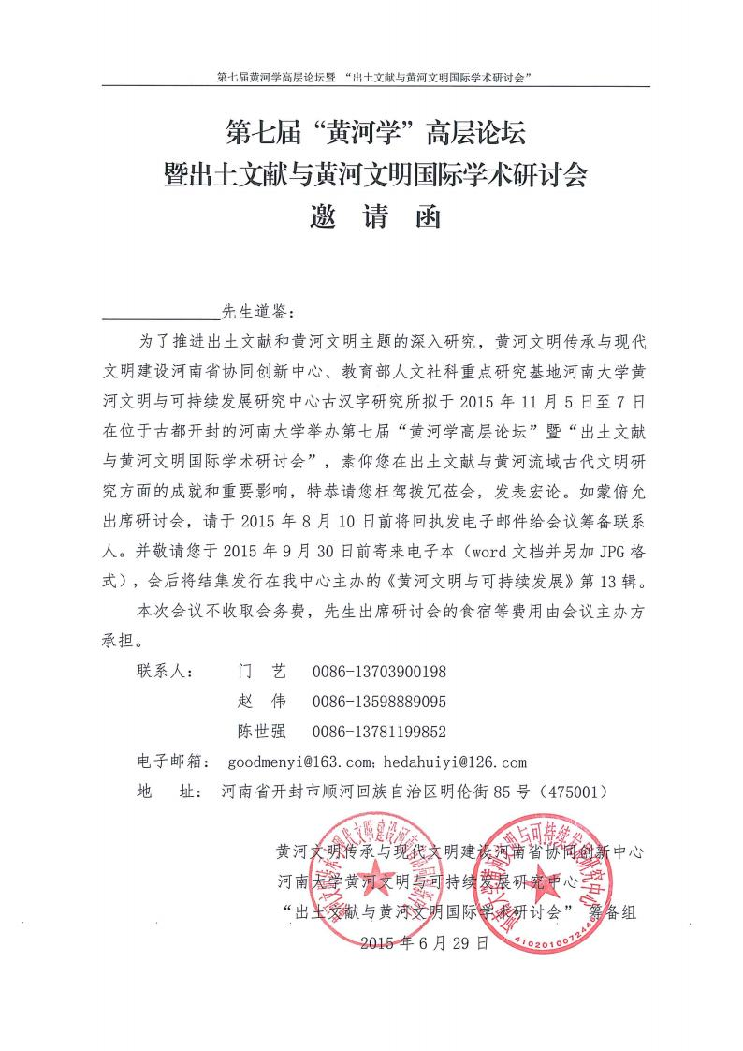

**回 执**

|  |  |  |  |
| --- | --- | --- | --- |
| 姓名(Name) | |  | |
| 国籍(Nationality) | |  | |
| 护照号(Passport Number) | |  | |
| 身份证号(National ID) | | 仅需中国大陆公民填写 (for Chinese mainland citizens only) | |
| 工作单位(Organization) | |  | |
| 职务/职称(Prefer Title) | |  | |
| 通信地址和邮编(Address&Postcode) | |  | |
| 电子邮箱(Email) | |  | |
| 电话(Phone) | |  | |
| 预留房间  （Reservation for a room）： | | 入住时间  check-in date | 退房时间check-out date |
|  |  |
| 论文  题目 |  | | |
| 论文提要  （300-500字） |  | | |